**Sales Process Case Study**

**Step:1:**

Import Excel Fille in Select the Tables and Click Transform Data

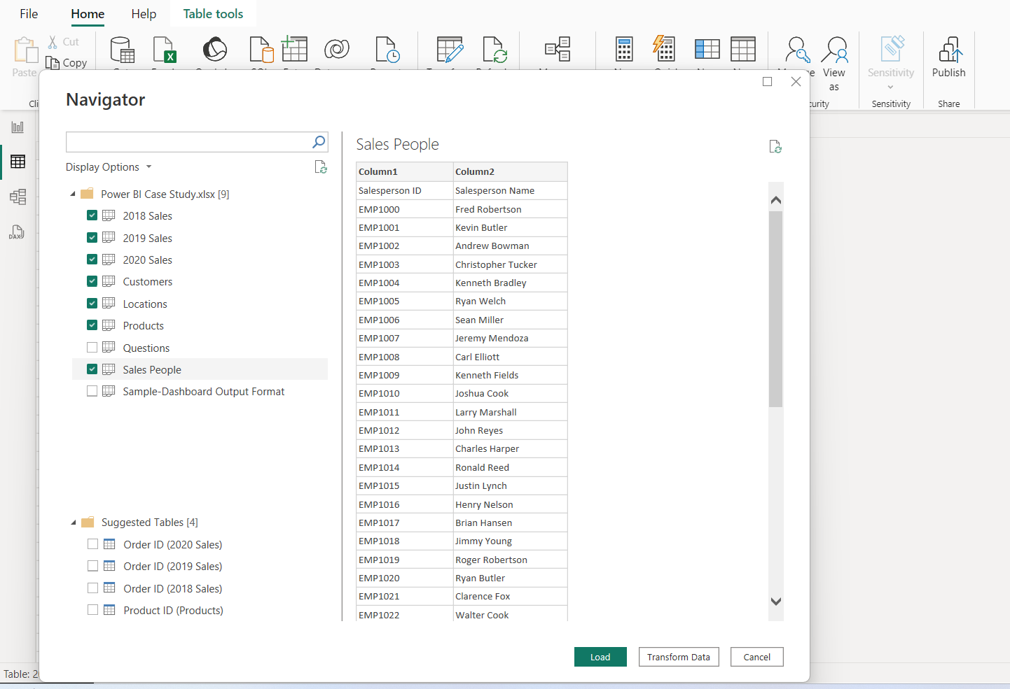

**Step 2:**

Select Each Table and make sure Each Table Header is First Row

If Not Select Use First Row as Headers

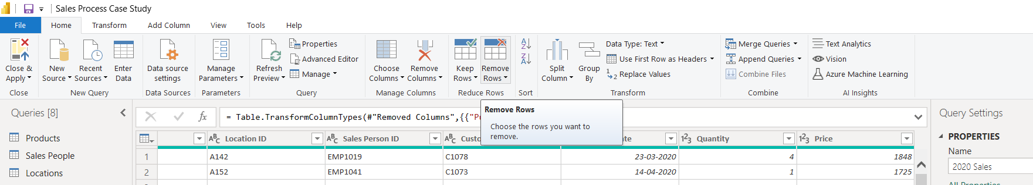



**Step 3**: If Anay Duplicate, Empty, Error Vales Please Remove it.

**Step 4:** Change the Porches Date Format

**Step 5:** Duplicate 2020 Table and Append the Three or more Colum’s and Add 2018,19 Tables

And Rename the Table Name Sales

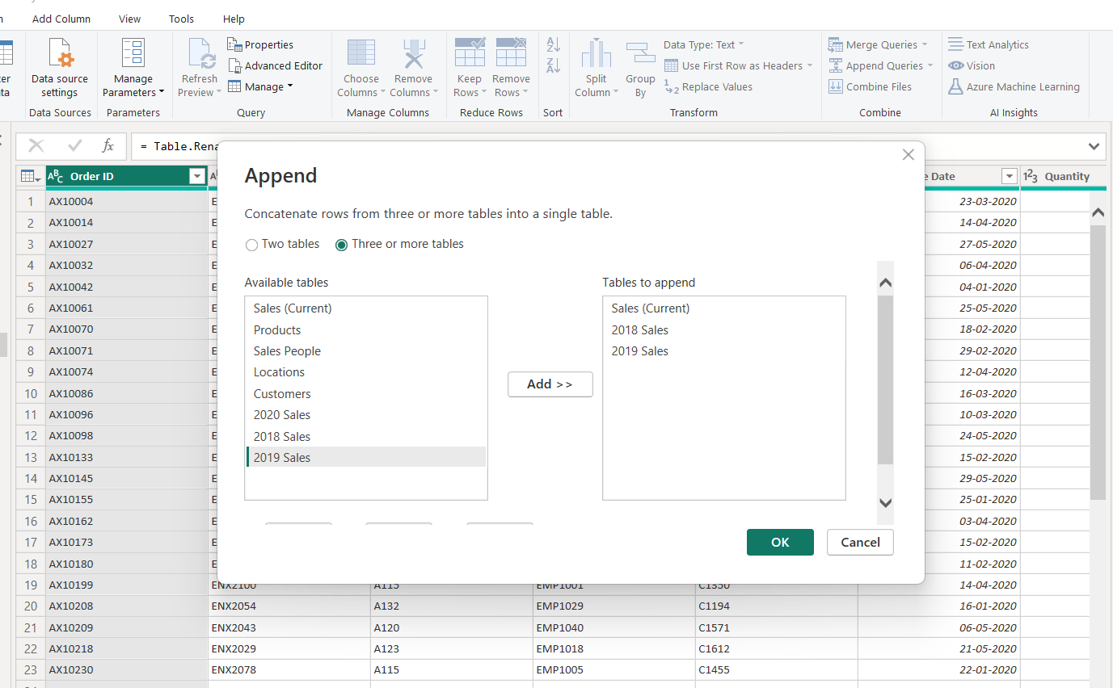

**Step 6:** Close and Apply

**Create The Relations on Sales to Each Table as per Below Image**

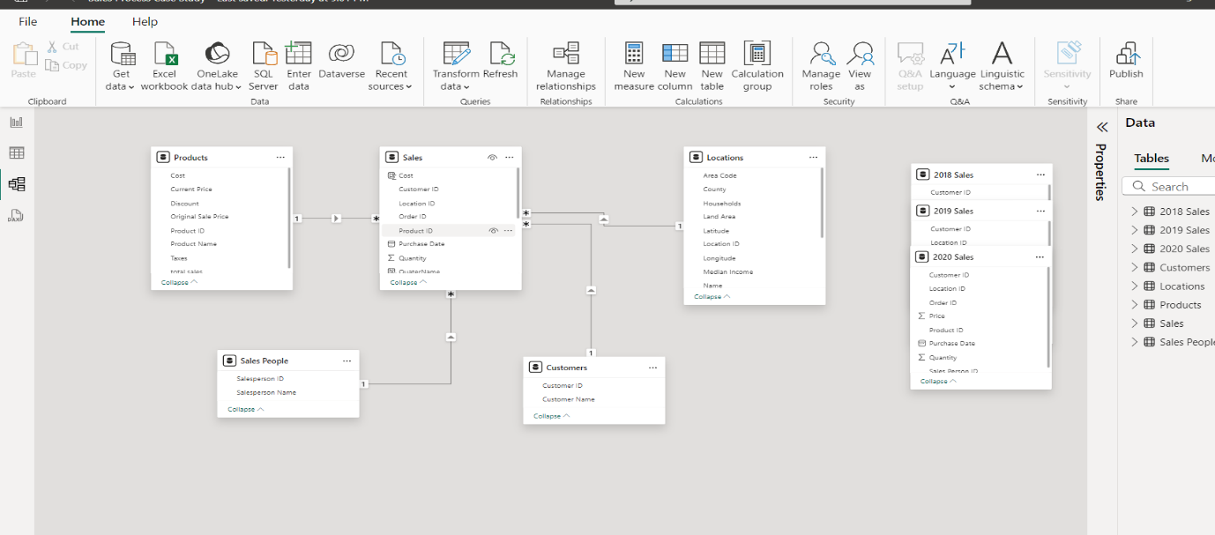

**Step 7:** In Sales Table Rename Price into Sales

**Step 8:** Add Coolum in Sales Table Use Below DAX Function Create Year

Year = YEAR(Sales[Purchase Date])

**Step 9:** Add Coolum in Sales Table Use Below DAX Function Create QuaterName

QuaterName = "Qtr"&QUARTER(Sales[Purchase Date])

**Step 10:** Add Coolum in Sales Table Use Below DAX Function Create Cost

Cost = RELATED(Products[Cost])

**Step 11:** Add Coolum in Sales Table Use Below DAX Function Create Taxes

Taxes = RELATED(Products[Taxes])

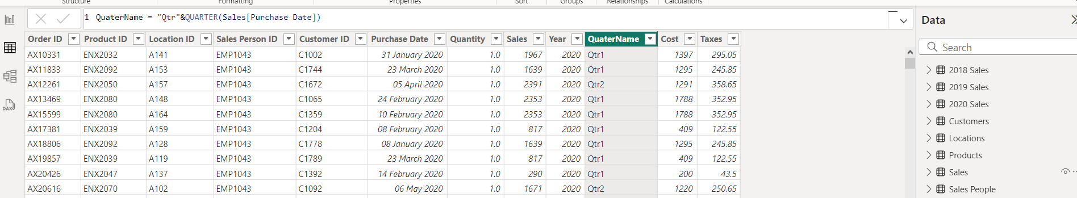

**Step 12:** **Create New Measure in Sales Using This Dax Function**

totalSales = SUMX(Sales,Sales[Quantity]*Sales[Sales])

Totalcost = SUMX(Sales,Sales[Cost]*Sales[Quantity])

Profit = [totalSales]-[Totalcost]

ProfitMargin% = DIVIDE([Profit],[totalSales])*100

**Prepare the Below Dashboard using above Functionalities**

